Java Program
EXP 1 — ATM System: Bug Report
Java Code
public class Main {
public static void main(String[] args) {
System.out.println("Bug ID: ATM004");
System.out.println("Test: Insufficient Balance");
System.out.println("Expected: Transaction Declined");
System.out.println("Actual: Cash Dispensed");
System.out.println("Status: FAIL");
}
}
Output:
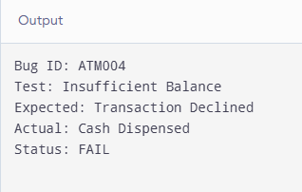
EXP 2 — VIANA Portal: Positive Test Cases
Java Code
import java.util.Scanner;

public class Main {
public static void main(String[] args) {
Scanner sc = new Scanner(System.in);

System.out.print("Enter username: ");
String username = sc.nextLine();

System.out.print("Enter password: ");
String password = sc.nextLine();

if (username.equals("student01") &&
password.equals("pass123")) {
System.out.println("Login Successful");
System.out.println("Dashboard Opened");
} else {
System.out.println("Login Failed");
}

sc.close();
}
}
Output:
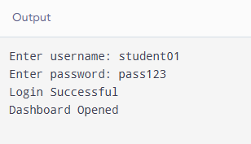
EXP 3 — VIANA Portal: Negative Test Cases
Java Code
import java.util.Scanner;

public class Main {
public static void main(String[] args) {
Scanner sc = new Scanner(System.in);

System.out.print("Enter username: ");
String username = sc.nextLine();

System.out.print("Enter password: ");
String password = sc.nextLine();

if (username.equals("student01") &&
password.equals("pass123")) {
System.out.println("Login Successful");
} else {
System.out.println("Invalid Username or Password");
}

sc.close();
}
}
Output:
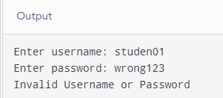
EXP 4 — Flipkart: Positive Test Cases
Java Code
import java.util.Scanner;

public class Main {
public static void main(String[] args) {
Scanner sc = new Scanner(System.in);

System.out.print("Enter product name: ");
String product = sc.nextLine();

System.out.print("Enter product price: ");
double price = sc.nextDouble();

System.out.print("Enter quantity: ");
int quantity = sc.nextInt();

if (price > 0 && quantity > 0) {
System.out.println("Product: " + product);
System.out.println("Total Amount: Rs." + (price * quantity));
System.out.println("Product Added to Cart");
} else {
System.out.println("Invalid Product Details");
}

sc.close();
Output:
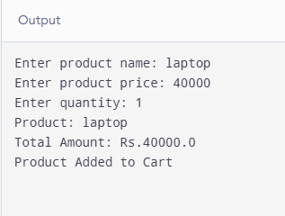
EXP 5 — Flipkart: Negative Test Cases
Java Code
import java.util.Scanner;

public class Main {
public static void main(String[] args) {
Scanner sc = new Scanner(System.in);

System.out.print("Enter product quantity: ");
int quantity = sc.nextInt();

if (quantity <= 0) {
System.out.println("Invalid Quantity");
System.out.println("Product Not Added to Cart");
} else {
System.out.println("Product Added to Cart");
}

sc.close();
}
}
Output:
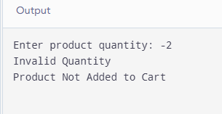
EXP 6 — Food Delivery Application: Positive Test Cases
Java Code
import java.util.Scanner;

public class Main {
public static void main(String[] args) {
Scanner sc = new Scanner(System.in);

System.out.print("Enter food name: ");
String food = sc.nextLine();

System.out.print("Enter price: ");
double price = sc.nextDouble();

System.out.print("Enter quantity: ");
int quantity = sc.nextInt();

if (price > 0 && quantity > 0) {
System.out.println("Food: " + food);
System.out.println("Total Amount: Rs." + (price * quantity));
System.out.println("Order Placed Successfully");
} else {
System.out.println("Invalid Order Details");
}
Output:
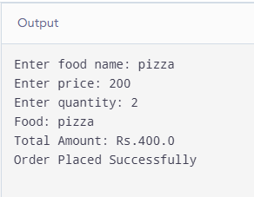
EXP 7 — Food Delivery Application: Negative Test Cases
Java Code
import java.util.Scanner;

public class Main {
public static void main(String[] args) {
Scanner sc = new Scanner(System.in);

System.out.print("Enter food quantity: ");
int quantity = sc.nextInt();

if (quantity <= 0) {
System.out.println("Invalid Quantity");
System.out.println("Order Rejected");
} else {
System.out.println("Order Accepted");
}

sc.close();
}
}
Output:
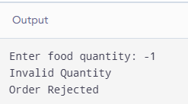
EXP 8 — Banking Application: Positive Test Cases
Java Code
import java.util.Scanner;

public class Main {
public static void main(String[] args) {
Scanner sc = new Scanner(System.in);

System.out.print("Enter current balance: ");
double balance = sc.nextDouble();

System.out.print("Enter deposit amount: ");
double deposit = sc.nextDouble();

if (deposit > 0) {
balance += deposit;
System.out.println("Deposit Successful");
System.out.println("Updated Balance: Rs." + balance);
} else {
System.out.println("Invalid Deposit Amount");
}

sc.close();
}
Output:
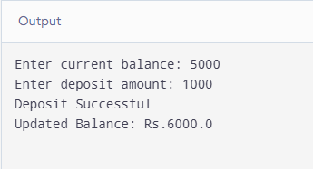
EXP 9 — Banking Application: Negative Test Cases
Java Code
import java.util.Scanner;

public class Main {
public static void main(String[] args) {
Scanner sc = new Scanner(System.in);

System.out.print("Enter account balance: ");
double balance = sc.nextDouble();

System.out.print("Enter withdrawal amount: ");
double withdrawal = sc.nextDouble();

if (withdrawal <= 0) {
System.out.println("Invalid Withdrawal Amount");
} else if (withdrawal > balance) {
System.out.println("Insufficient Balance");
System.out.println("Withdrawal Rejected");
} else {
balance -= withdrawal;
System.out.println("Withdrawal Successful");
System.out.println("Remaining Balance: Rs." + balance);
}

sc.close();
}
}
Output:
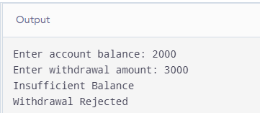
EXP 10 — Library Management System: Test Plan
Java Code
import java.util.Scanner;

public class Main {
public static void main(String[] args) {
Scanner sc = new Scanner(System.in);

System.out.print("Enter available books: ");
int available = sc.nextInt();

System.out.print("Enter books to issue: ");
int issue = sc.nextInt();

if (issue > 0 && issue <= available) {
available -= issue;
System.out.println("Books Issued Successfully");
System.out.println("Remaining Books: " + available);
} else {
System.out.println("Book Issue Failed");
}

sc.close();
}
Output:
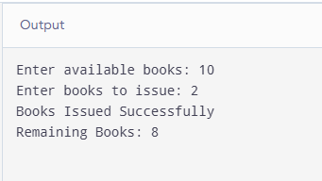
EXP 11 — Railway Reservation System: Positive Test Cases
Java Code
import java.util.Scanner;

public class Main {
public static void main(String[] args) {
Scanner sc = new Scanner(System.in);

System.out.print("Enter source station: ");
String source = sc.nextLine();

System.out.print("Enter destination station: ");
String destination = sc.nextLine();

System.out.print("Enter number of seats: ");
int seats = sc.nextInt();

if (!source.equalsIgnoreCase(destination)
&& !source.trim().isEmpty()
&& !destination.trim().isEmpty()
&& seats > 0) {
System.out.println("Source: " + source);
System.out.println("Destination: " + destination);
System.out.println("Seats Booked: " + seats);
System.out.println("Ticket Confirmed");
} else {
System.out.println("Invalid Booking Details");
}

sc.close();
}
}
Output:
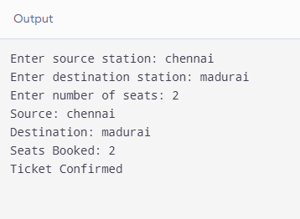
EXP 12 — Railway Reservation System: Negative Test Cases
Java Code
import java.util.Scanner;

public class Main {
public static void main(String[] args) {
Scanner sc = new Scanner(System.in);

System.out.print("Enter source station: ");
String source = sc.nextLine();

System.out.print("Enter destination station: ");
String destination = sc.nextLine();

System.out.print("Enter number of seats: ");
int seats = sc.nextInt();

if (source.equalsIgnoreCase(destination)) {
System.out.println("Invalid Journey");
} else if (seats <= 0) {
System.out.println("Invalid Seat Count");
} else {
System.out.println("Booking Details Accepted");
}

sc.close();
}
}
Output:
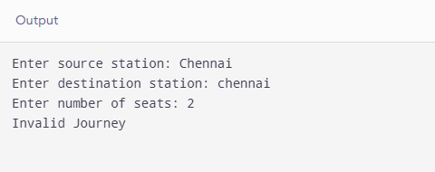
EXP 13 — Online Examination System: Positive Test Cases
Java Code
import java.util.Scanner;

public class Main {
public static void main(String[] args) {
Scanner sc = new Scanner(System.in);

System.out.print("Enter total questions: ");
int total = sc.nextInt();

System.out.print("Enter correct answers: ");
int correct = sc.nextInt();

if (total > 0 && correct >= 0 && correct <= total) {
System.out.println("Exam Submitted Successfully");
System.out.println("Total Questions: " + total);
System.out.println("Correct Answers: " + correct);
System.out.println("Score: " + correct);
} else {
System.out.println("Invalid Exam Details");
}

sc.close();
Output:
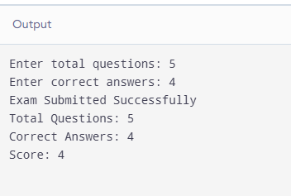
EXP 14 — Online Examination System: Negative Test Cases
Java Code
import java.util.Scanner;

public class Main {
public static void main(String[] args) {
Scanner sc = new Scanner(System.in);

System.out.print("Enter username: ");
String username = sc.nextLine();

System.out.print("Enter password: ");
String password = sc.nextLine();

if (username.trim().isEmpty() || password.trim().isEmpty()) {
System.out.println("Username or Password Missing");
System.out.println("Login Rejected");
} else {
System.out.println("Login Details Accepted");
}

sc.close();
}
}
Output:
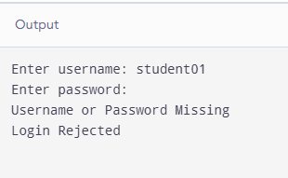
EXP 15 — Inventory Management System: Test Plan
Java Code
import java.util.Scanner;

public class Main {
public static void main(String[] args) {
Scanner sc = new Scanner(System.in);

System.out.print("Enter initial stock: ");
int stock = sc.nextInt();

System.out.print("Enter quantity sold: ");
int sold = sc.nextInt();

if (stock < 0 || sold < 0) {
System.out.println("Invalid Stock or Quantity");
} else if (sold > stock) {
System.out.println("Insufficient Stock");
} else {
stock -= sold;
System.out.println("Sale Successful");
System.out.println("Remaining Stock: " + stock);
}

sc.close();
}
Output:
